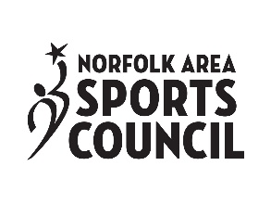
GRANT GUIDELINES AND APPLICATION
PURPOSE OF FUNDS: The purpose of the Norfolk Area Sports Council INCENTIVE FUND is to provide funding to be used to entice groups to choose the Norfolk Area/Madison County as a location for tournaments and sporting events, including but not limited to, tournaments and sporting events. The funds available through this program are provided through the Sports Council and lodging/occupancy tax collected by lodging/camping facilities in Madison County.
USE OF FUNDS: INCENTIVE FUND grants are to be requested by community leaders, meeting/attraction facility managers, Conventions Visitors Bureau (CVB) staff and community members. The amount granted will be offered directly to the event organizers through the inclusion of an award letter sent to requesting party by the CVB for inclusion in bid proceedings.
CRITERIA: Funds will be awarded for use in enticing a specific tournament, and sporting event and will be based on estimations of the following criteria:
- Attendance
- Percentage of attendees from outside Madison County
- Number of hotel lodging nights to be used by vendors and attendees
- Number of camping nights used by vendors and attendees
- Promotion and use of local attraction and facilities
- Use of local suppliers/service providers
- Time of year
- Number of meals off-site
- Propensity for attendees to shop
Funds provided by NAVB may not be used for:
- General operating expenses
- For additional or current personnel salaries
- For items not included in the approved grant application
- In any manner that would violate the Nebraska Visitors Development Act, Neb. Rev. Stat. 81-1245 through 81-1263, et seq. (as amended from time to time)

APPLICATION PROCESS:
APPLICATION: Each applicant must include the completed application, an event description (no more than one page), a budget worksheet and a copy of the proposal submitted by event organizer if applicable.
DEADLINES: New event applications are to be submitted at least 60 days prior to your event to the Norfolk Area Sports Council. Recurring events (received funding in the past) must have their applications turned in on or before the first Friday of January.
PRESENTATION: Applicants may be required to present at a board meeting at which their application is reviewed. Presentation must not be longer than 10 minutes.

REPORTING, ACCOUNTING AND PAYMENT PROCEDURES:
REPORTING: Thirty days after the completion of the event, a report will be submitted to the Norfolk Area Sports Council and the Visitors Bureau giving final results including; estimations based on grant criteria and an overall profit/loss for the event if applicable (see Norfolk Area Sports Council Grant Report Form).
PAYMENT: Payment will be made directly to the organization or to the facility hosting the event. Payment will be made after the completion of the event and the receipt of the Norfolk Area Sports Council Grant Report Form has been received by the Norfolk Area Sports Council or the Norfolk Area Visitors Bureau, unless other arrangements have been made.
REVIEW PROCESS: Funds are governed by the Norfolk Area Visitors Bureau and Norfolk Area Sports Council Advisory Committee and are discretionary, based upon available funds; other anticipated uses and anticipated effectiveness of the proposed event.

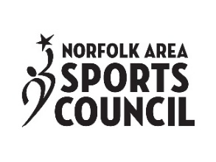
Grant Application

- General Information
Name of Organization: _______________________________________________________________________________
Check Payable to (If different than above):________________________________________________________________
Address: ____________________________________________________ City: ________________ State: ____________
Phone: _________________________________________________ Website: ___________________________________
Email: _____________________________________________________________________________________________
Contact Person: ______________________________________________ Title: ________________________________
Address contact person or person completing application (include address for check if different)
Address: ____________________________________________________ City: ________________ State: ____________
Phone: __________________________________________ Email:____________________________________________
Name of project/event: ______________________________________________________________________________
Dates of project/event:_______________________________________________________________________________
Has this event previously been held in the Norfolk area? (YES) (NO)
Amount Requested: _________________________________________________________________________________
Sports Council bags requested (YES) (NO) If yes, quantity: _____________________ Date needed by:_______________

- What is the mission of your organization?

- How long has the organization been in existence? Please also give a brief narrative discussing events the organization has hosted or put on in the past.

- If your organization has been the recipient of grants from (from Norfolk Area Visitors Bureau, Sports Council or other entities) in the past, please indicate amounts, funding organizations, and projects.

- Please provide a brief description of the project for which you are applying. Be sure to specify how the grant monies will be used and how the project will enable recipients to further the mission of the Norfolk Area Sports Council. If the lay person is unable to see how this project/event is sports, please use this opportunity to describe.

- Please provide the best possible projections / estimates for the following:
- How many athletes & coaches will travel MORE than 100 miles for the event? ____________________________
- How many spectators will travel MORE than 100 miles for the event? ___________________________________
- How many athletes and coaches will travel LESS than 100 miles for the event? ____________________________
- How many spectators will travel LESS than 100 miles for the event? ____________________________________
- How many participants that traveled LESS than 100 miles are from Madison County? ______________________
- Total number of anticipated motel rooms used by visitors: Attendees ________ Vendors________
- Estimated number of camping nights: Attendees________ Vendors_________
- Local attractions/facilities utilized during event: ____________________________________________________ ___________________________________________________________________________________________
- Local vendors and/or suppliers utilized for this event: ________________________________________________
___________________________________________________________________________________________
- Anticipated community participation: _____________________________________________________________
- Describe how the event will be marketed.

- If awarded funds, how will you recognize the Sports Council for the funds received?

- Please compete the budget projection worksheet that is included on the next page. Please note that except in very few cases, Sports Council funds should not be sole source of funding.

Projected Financial Report
Income:
Entry Fees | $
Program Advertising | $
Grants (Specify on back if other than NAVB/SC) | $
Sponsorships | $
Admissions | $
Program Sales | $
Merchandise Sales | $
Concessions Sales | $
Other | $
Projected Total Income: | $

Expenses:
Bid / Guarantee Fees | $
Sanctioning Fees ** | $
Facility Rental | $
Custodial Fees | $
Equipment Rental | $
Insurance | $
Officials / Judges Fees | $
Transportation | $
Hotel | $
Meals | $
Awards / Prize Money | $
Postage | $
Phone Utilities | $
Concessions / Programs | $
Other (Please Itemize on Back) | $
Projected Total Expenses: | $
**Fee paid to governing body per team / participant
Projected Net Profit (Loss): $_________________
- If the above report indicates a profit, how will those profits be used to create, grow, improve or market future events?

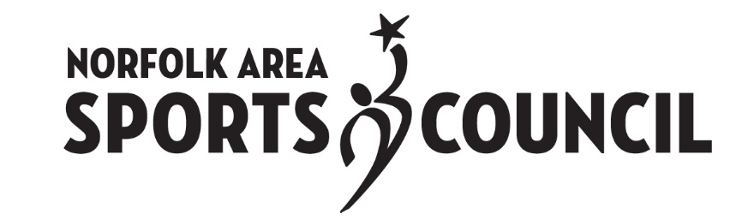

Norfolk Area Sports Council Grant Report Form
(For Completion Following the Event)

Grant report form must be completed within 60 days of the completion of the project and submitted to the Norfolk Area Visitors Bureau and Norfolk Area Sports Council.

- Please give a brief overview of your event.

- How were funds granted by the Sports Council used?

- Number of athletes/coaches/team staff participating in the event: __________________________________
- Number of spectators who attended the event: _________________________________________________
- Number of participants that traveled more than 100 miles for the event: _____________________________
- Number of spectators that traveled more than 100 miles for the event: ______________________________
- Number of participants that traveled LESS than 100 miles for the event: ______________________________
- Number of spectators that traveled LESS than 100 miles for the event: _______________________________
- Number of participants from Madison County: __________________________________________________
- Number of spectators from Maison County: ____________________________________________________
- How did your event change / grow from previous years?

- Is there anything with your event that didn’t work out as planned or that you would do differently in the future?

Expenses:
Bid / Guarantee Fees | $
Sanctioning Fees ** | $
Facility Rental | $
Custodial Fees | $
Equipment Rental | $
Insurance | $
Officials / Judges Fees | $
Transportation | $
Hotel | $
Meals | $
Awards / Prize Money | $
Postage | $
Phone Utilities | $
Concessions / Programs | $
Other (Please Itemize on Back) | $
Total Expenses: | $
**Fee paid to governing body per team / participant
Net Profit (Loss): $_________________
- If you are projecting a profit, how will that money be used to market, grow or improve your event / other events in the future?

